Post Graduate Diploma in Teaching (ESOL)
Theories and Frameworks- Assignment 2

Name: Sameera Sharif
Student number 10432611
Date: 17/12/14
Number of words: 5190

Contents
Part 1- essay page 3-14
Part 2- written text analysis page 15-16
Part 2- spoken text analysis page17-19
Part 2 Justification of lesson plan page 20-23
References page: 24-25
Appendix
Case study page: 26-34
Article: page: 35-37
Table 1 (written text) page: 38-40
Table 2 (spoken text) page: 41-43
Lesson plan page: 44-54

Identify two or three puzzles/concerns within your own practice. Critically examine how theories of learning and second language acquisition could shed light on these concerns and assess their relevance to your practice. Use the case study as an appendix to illustrate your points.

One of the fundamental roles of a teacher is to facilitate learning so as to enable learners to take responsibility for their own learning, so that they can work autonomously. Petty (2009) agrees and states that learners should be “encouraged to be active rather than passive in their attitude to learning”. Teachers are discouraged to make their lessons teacher led and instead make the class learner centred. However the question remains as to how autonomy can be achieved. There are also concerns as to whether teachers should ensure accuracy over fluency or vice versa, and also what the best way is to correct errors. This essay will explore these concerns and analyse how theories of learning and second language acquisition could help in understanding these concerns and assess their relevance in our practice.
Hedge (2000:76) defines the characteristics of an autonomous learner as a learner who can “take responsibility for learning”. This learner must have “the ability to define one’s own objectives”, must be aware of how to effectively utilise materials for language use and be a good organiser of time, and be able to decide what the best strategies are for active learning. These strategies include “cognitive, metacognitive, communication strategies and socio-affective strategies.” These strategies have been recommended for the case study learner (see pages 2-33).
To make the learners be more autonomous is to adopt the Communicative Language Teaching (CLT) method in the classroom. The sociolinguistic revolution led to the emergence of CLT. (Johnson (2001:182). It concerns itself with the “knowledge” learners have “acquired in communication” (Ellis 1997:60). Nunan (2004:7) states that CLT consists of a “family of approaches, and that the initial methods focused on the “end products”, CLT deals with “learning processes”. Mitchell and Myles 1998:94) define communication strategies as “tactics” that are adopted by the learner who is not so fluent to “overcome specific communicative problems”.
Task Based Learning (TBL) which is derived from Communicative Language Teaching (CLT )is a method that can be employed to make learners more autonomous. Ellis (2000) states that TBL is derived from the Socio-cultural theory, in that the learners, “co construct the activity” they are doing “in accordance with their own socio-history and locally determined goals”. He continues to state that this theory “emphasizes the dialogic process (such as scaffolding).

Ellis (2000):4, defines a task as a

“‘work plan’; that is, it takes the form of materials for researching or teaching language. A work plan typically involves the following: (1) some input (i.e. information that learners are required to process and use); and (2) some instructions relating to what outcome the learners are supposed to achieve.”

Willis (1998:1) simply defines TBL as a “goal orientated activity with a clear purpose”. An outcome is to be achieved whilst doing a communication task, “creating a final product that can be appreciated by other”. Nunan (2004: 4) defines TBL of having the intention of conveying “meaning rather than to manipulate form”.
Promoters of TBL argue that to engage learners in “real language” use is the “most effective way to teach language” (Willis &Willis) 2007 :1. TBL can be used to teach all four skills. Learners are encouraged to work in pairs and in groups, but can also be taught within a teacher led classroom as shown by N.S.Prabhu who has successfully used TBL “within the class as a whole” (Willis & Willis 2007:3).
In a TBL lesson, 3 stages are involved. These are the pre-task, the task cycle, and the language focus. This is considered simply by Willis (1994):19 cited in Harmer (2007:71) as a “sort of PPP upside down”. This type of learning is different from the traditional PPP model (Presentation, Practice, and Production) in that a task based lesson the teacher does not “pre-determine what language will be studied” (Frost 2004:1).
In the language focus stage the students will complete activities which are consciousness-raising. (CR). CR is where the “attention of the learners is deliberately directed at features of language” Thornbury (n.d)
However Nunan (2004:chap 2) cites a different framework in that it begins with a pre-task followed by controlled practice for vocabulary. The learners then listen to an authentic text and then “focus on linguistic elements”. After that they do some freer practice and then finally the pedagogical task is introduced.
Examples of such tasks include “spot the difference”, by asking each other questions. (Bilbrough 2007:6) .Other examples include listing, sorting, classifying, matching, comparing, and problem-solving, projects and storytelling.
However critics such as Littlewood (2004a) cited in Harmer (2007:73) argue that there is a confusion between the task sequences of TBL, for example as in the above case of Willis and Nunan, and thus it seems there is confusion of what TBL means. Michael Swan cited in Harmer (2007:73) feels that TBL is significantly “less effective for the systematic teaching of new language”.
Thornbury (2005:121) states that other approaches such as genre-based approaches “attempt to redress” some of the criticisms of TBL, by providing “direct instruction”. Instructions begin by “establishing the social purpose and cultural context of the genre in question.” Paton and Wilkins (2009: 124) add that reading and writing can be taught using the genre approach. Whilst reading the learners can identify the “generic features” of the text and then they can “predict and use these features to make meaning from texts”. This theory also works with writing in that learners reconstruct the genre “to produce new texts”. However they point out the genres change over time and state that “genres should not be taught as a set of fixed rules”
Thornbury, (2005) however adds that this approach has also been criticised as have the product based approaches, in that it the “focus on imitating models does not necessarily reflect the way the way the writers (and speakers) produce texts (or talk) in reality.” However due to the merits of this approach, it has been recommended for the learner from the case study (see appendix page 29). The learner wants to work as a professional teacher in the UK, and also wants to promote cultural tourism in Argentina and the UK. She may have to give formal presentations and write articles and reports, and read and mark essays. She will also have to write a CV for herself. Showing her authentic examples of CV’s where she can analyse the text, and discuss its key features. She can then reconstruct a CV for herself if she chooses to use the authentic examples or not.
However despite the criticisms of TBL, and genre based approaches both task based learning and genre based approaches have been recommended as a strategy for the learner in the case study (see appendix pg 29).Thornbury (2005:119) recommends tasks such as conduction of interviews, giving short presentations, creating reports, giving opinions and writing reviews all important to the needs of this learner as she wants to teach in the UK.
Although TBL has been recommended to the learner and it is an approach that clearly works. I have not yet fully adopted this method in my teaching. I use elements of this method but I feel I need far more experience yet to be able to be fully confident in applying it.
I use the genre-approach method with my students .For example I used authentic samples of CV’s to show to my students before we could begin to construct their CV’s. They were able to correct mistakes on the originals, and discuss the layout and terminology used.
Another method that can be highly effective is the ESA (Engage, Study and Activate) method. Harmer (2007: 66) explains that learners need to be “emotionally engaged” if successful learning is to take place. Study is when the teaching and learning take place once “focus is on how something is constructed”. These activities can be a focus on form or fluency. Activation takes place when the student is encouraged to use all the language they know. This is where communicative tasks are utilised. Teachers can use various sequences to their lesson One of them is the “straight arrows lesson procedure” (Harmer 2007:67) where the sequence is similar to the PPP sequence. Additional sequences include the “Boomerang” procedure which follows a more “task-based or deep-end approach”. The third sequence is the patchwork lesson procedure where the learners are engaged before they are asked to activate their knowledge and then they are re-engaged by the teacher before they learn some more.
This is a popular method within my teaching practice. I mainly use the straight arrows technique with lower level classes and the boomerang and patchwork technique with higher levels. to engage the learners I ask them to play games such as the alphabet game, make lists, and discuss issues. For the study stage I use the board to teach the lesson and cover any gaps in knowledge and then ask concept check questions to check understanding. The learners do gap-fill, matching, and word order exercises. To activate the learners, I ask them to take part in role plays, debates, and conduct surveys.
Humanistic approaches can also develop “student autonomy and gives the responsibility for learning to the student” Petty (2009: 367). He also states that the humanistic approach places a “high value” on “emotional factors and personal growth and development”. This approach encourages self direction and self governance. He emphasises that the “facilitating role of the teacher is crucial” and that the teacher has to “ready to help the student towards independence”. (Petty 2009:368).
My style of teaching is quite humanistic in that I am able to develop my learner’s self-esteem, and make sure they have high efficacy. The methods I use are participatory and discovery methods and this leads to a learner centred class, where student’s feelings and aspirations are respected
Nunan ( 2004:12) states that Experiential learning is another approach which takes the learners “immediate personal experience as the point of departure for the learning experience”. He says that learners play an active role in their learning and “engage in and reflect on sequences of tasks”, and thus they are “learning by doing”. This led to Kolb’s four stage model which “combines reflection with experience” and it can begin at any stage of the process (Reece and Walker 2006:92 cited in Malthouse and Barentsen 2013:6) The stages are doing it, reflecting on it, reading upon it and then planning the next stage. Malthouse and Barentsen(2013:13) state that reflective practice “benefits” one’s own “
“learning, problem solving skills, your critical thinking, decision making, organisational skills or your personal change management”.
Asking the students to reflect and give feedback on what they have learned and what they need to next is important in making students more autonomous. It gives them control of their learning process.
This approach is recommended for the learner in the case study (see page 30). The learner is highly intellectual and is a professional teacher. She has high cognitive skills that can enable her to reflect her learning. She can do this by writing a reflective journal of what she has learnt, and any experiences she has had. She can contribute to blogs and forums on line.
I have implemented this in my classroom as I usually teach level 2 students who are all university graduates and thus they have the cognitive skills to be able to reflect on their learning, and are able to assess and evaluate their work.
Another concern for many teachers and a question that is asked by Hedge (2000:47) is how to aim to get a “balance between “focused” or “form focused classroom activities which aim at linguistic accuracy and unfocused activities which involve learners in negotiation of meaning and aim at fluency”.
Lightbown and Spada (1993:80) state that,
“it was the frequent failure of traditional grammar translation and audio-lingual methods to produce fluency and accuracy in second language learners which led to the development of more communicative approaches to teaching in the first place”.
This is agreed by Ellis (1997) who states form- focused instruction methods which were “delayed production” approaches “frustrated” many students.
Hedge (2000:54) defines fluency as relating to “language production which is reserved to speech”. She says a student is fluent when they can “link units of speech together with facility and without strain or inappropriate slowness or undue hesitation”. Brumfit (1984) cited in Hedge (2000:57) states that there should be “natural language use” and this can be achieved by “fluency activities” which develop
“a pattern of language within the classroom which is as close as possible to that used by competent performers in the mother tongue in real life”.
He believes that focus should be on “meaning and not on form” and that learners should decide what they want to learn and they have to think of ideas and express opinions.
Prabhu (1987) cited in Hedge (2000:58) gives examples of fluency based activities. These include information-gap”, “reasoning-gap and opinion gap activities.
Thornbury (2000) states, that accuracy is achieved when the learner has devoted some “attention to form, ie, getting it right”. He continues to state that accuracy “requires attention” and “attention needs time”. He says that research has shown that the more time a student has the more accurate they become. He continues to state that the more time a student has the more accurate they become. Students should be given time to “plan monitor and fine-tune their output”. Thornbury (2000:92). He also felt that without accuracy students may end up being “unintelligible”, and thus teachers must give “unambiguous” feedback and correct errors which will help learners to pay more attention to form.
Hedge (2000:60) agrees with Thornbury in that students should be given time to prepare what they are going to say, and also that the teacher should provide activities to focus on form after the communicative task. She also adds that students can also record themselves and then listen back to examine their errors. This strategy has also been recommended for the student in the case study (see page 28).
Willis and Willis (2007: 31) who are ardent promoters of Task based learning state that Task Based learning allows for “a focus on accuracy and a focus on form”.
Paton and Wilkins (2009:156) also recommend lexical approaches where students try and recognise and memorise lexical chunks. They feel that this approach will suit fluent learners who are not so accurate. They state the reason that this approach would work well for such learners is because “primacy of meaning in a lexical approach is likely to make sense” to these learners. It is also a “new way of looking at difficult areas of grammar”. For example if the learners look at the way articles and prepositions join with other words seems to be easier compared to remembering the rules. They conclude by saying that,
“if a learners speech contains a high proportion of lexical chunks, accurately produced, speech will be both more fluent and more accurate”.
This approach is relevant to the learner in the case study as she has a good understanding of rules but finds them difficult to apply. Learning lexical chunks will help her to be more fluent and with time more accurate.
Corder (1973) cited in Willis and Willis (2007:31) also argues that that students need to have “confidence and fluency” to be able to “acquire a valuable skill for life”, and continue to learn. Willis and Willis (2007:32) state that this can be achieved by allowing the learners to have many chances to use their language in their lessons which “rewards successful use and does not penalize inevitable failings in accuracy.”
One way of ensuring accuracy and fluency is to correct errors. The teacher has to have a good understanding of morphology and syntax to be able to identify grammatical errors. (Paton and Wilkins 2009:142). Thornbury (1999: 126), adds that not all errors are grammar errors and that different errors need a different response.
Willis and Willis (2007:228), give advice on accuracy and correction. They state that learners should be allowed to make mistakes as its “all part of the fluency process”. They also state that teachers should “hold back” and not correct errors as soon as they hear them, and should not interrupt a learner whilst they are speaking. Instead the teacher should write down “a few common errors” whilst listening and “correct supportively” later in the lesson. However I asked my students if they would like to be corrected straight away or later, and the overwhelming response was that they wanted to be corrected straight away.
Thornbury (1999:115) student can “self correct” their mistake, if asked by the teacher to do so. Students can be encouraged to “peer correct” and give feedback. I usually ask my students to mark each other’s written work and identify mistakes. However I am careful of making sure the students are comfortable with marking each other’s work. Thornbury (1999:126) advices the teacher to make sure that the feedback is positive and not negative, which will have a “damaging effect on the learner’s language development”. He states that teacher can also ask the learner to clarify what they have said and can also ask them to reformulate their sentences.
I usually use all of the techniques mentioned above but I have been observed as not doing enough correction. I need to develop and gain more experience and confidence in this area.
After having researched studies, Lightbown and Spada(1993) have come to the conclusion that they prefer to “get it right in the end” as compared to getting it “right from the beginning”, as the former is “not a very effective way to provide second language instruction”. The getting it right at the end approach” is based on the idea that learners need “exposure” to the language and “opportunities to use language meaningfully”. They strongly feel after many years of experience that grammar based approaches “do not guarantee that learners develop high levels of accuracy and linguistic knowledge”. Lightbown and Spada (1993: 83).
Although meaning is given primary importance, focus on form should also be provided “within communicative contexts.” It is up to the teacher to “find the right balance between meaning-based and form Focused activities”, allowing the learners to have many chances to use their language in their lessons which “rewards successful use and does not penalize inevitable failings in accuracy.” (Lightbown and Spada 1993) .Hedge (2000) also agrees in that she feels that to create a balance between accuracy and fluency, both preparatory and follow-up activities should be used.
In conclusion it can thus be seen from research that in order to help the learner become more autonomous, communicative language methods are more effective than the traditional methods. These methods include task-based approaches, genre-based approaches, ESA approaches and lexical approaches. Experiential learning is also an effective approach for learner autonomy. Strategies such as cognitive, metacognitive, socio affective strategies are also important. The debate whether accuracy should prevail over fluency is summarised by Paton and Wilkins (2009:133) who state that “successful communication must involve a high degree of accuracy.” They thus state that accuracy and fluency “are closely linked” for the student.

Part 3: Written text analysis
The authentic written text is taken from www.johngoddard.info. (see appendix page 35-37)
It is to be used for students who are studying at level 2.
Table 1 (see appendix page 38-40) has a full list of examples and explanations.
The text is called “The world’s greatest goal achiever”, and it is a formal written narrative for the purposes of explaining the achievements of John Goddard. It is linked to a lesson that the students did on Steven Sutton (see listening text). Its purpose is to inform, with limited use of emotions and is written in a factual manner. It recounts the life story of Mr Goddard. It is very descriptive and gives precise numbers such as “63,000 feet”, and 140 degrees.
The main tenses used are the past tense since this is a story of a man who is not longer alive. Please see table 1page 37 for examples of all tenses and aspects.
The information provided is not assumed and is subject specific and explicit. Jargon such as “goal achiever”, “explorer”, “adventurer”, “anthropologist”, “and survivor”, are used to describe Mr Goddard.
The text is cohesive as his name “Goddard” has been repeated often.
Anaphoric references are made to Mr Goddard by using the pronoun “he”.
The sentences in this text are complete. Most of the sentences are simple and compound sentences with some examples of complex sentences (see table 1 page 37-38). There is use of correct punctuation and use of paragraphs. There are no contractions. It is organised and there is no vague language and conforms to the conventional uses of grammar and the vocabulary is precise. The writing uses a generally acceptable standard variety of the language.
The text is written in the active and passive form. The text uses numerous active verbs to tell the reader what Mr Goddard did. These include, “documented” “showed”, “sat down”, “climbed”, “conducted”, “traversed”, “visited”, “studied”. Passive verbs are also used to show what happened to Mr Goddard by animals, other humans, and the weather. (See table 1 page 40 for full list).
Adjectives are used to describe nouns and noun phrases and are used in many occasions in the text. These make the text more specific and more interesting to read. These include, “amazing”, “vicious”, treacherous”, “adventurous”, “poisonous”, “rampaging”, “raging”, “blinding”.
Superlatives are used to express the degree of the adverb or adjective and words such as “longest”, “highest”, greatest”, “most” are used. They have been used to emphasise Goddard’s qualities and achievements, in that they exceed all others.
Nouns and noun phrases are used to inform the reader of names of people and places (see table 1 appendix page 39 for examples)
It is clear that this text is a written text because it does not have the features of spoken text such as back channelling, discourse markers, ellipses, and fillers and so on. The next text which is a spoken text has these features.

Spoken text analysis
Steven’ s Story
http://www.youtube.com/watch?v=MvG3ifEd0t0 (4 minutes of analysis)
See table 2 appendix page40-42 for examples and explanation.
Steven’s Story is a television documentary about the real life story of Steven Sutton. This video was on his website www.justgiving.com and also on YouTube. It is a documentary about Steven’s life since he was diagnosed with cancer. Steven was a teenager who wrote a bucket list and raised money for teenage cancer. The audience is the general public, mainly teenagers and adults. The purpose is to inform the public and raise awareness of his charity work and tee Steven became a household name after he appeared on the news.
Steven is the person who introduces the documentary. He uses the first person singular “I” as it is a personal narrative to begin with. However there are other people who speak in the video about Steven and these include Steven’s mother, Emma Scholes (head of year 9) Tim Dowling (head of sixth form) Stewart Jones his head teacher, and Lee Woodward a local fundraiser. The documentary does not introduce these other people as their names just appear on the screen, so if you were just listening to the documentary the speakers would not be apparent. The text has probably been edited to just include just the relevant information.
The speakers are all native speakers with English as their first language. Stephen is from the West Midlands (Stafforshire).The topic is serious and a bit sombre and thus there is no show of excitement and surprise, although Stephen does try to sound light hearted.

The documentary is not a dialogue between people, but a documentary with short interviews, and thus some examples of features of spoken discourse are not identified. These include back channelling-short words to show active listening, discourse markers-to mark boundaries from one topic to the next, ellipses- missing out words to avoid repetition, interactional language-social and personal to establish and maintain interpersonal relationship, incomplete sentences and tags which are questions to establish a shared view of things or to seek confirmation.
The main tenses are used are the past simple and past continuous and the present simple, present perfect simple, and the present perfect (please see table 2 page 42)for examples.
Colloquial language, or slang words or neologisms are not identified. All the speakers are well spoken. Steven does use some informal language such as “kick up the backside”.
Words mainly nouns and adjectives and verbs which carry meaning such as “cancer”, “story”, “chemo”, “positivity”, “suffering”, “bucket”, “exceptional”, are stressed by the speakers.
Examples of intonation include:
“Stephen Sutton was an exceptional student, exceptional in academic terms securing some of the best results we have ever seen in the history of this school.”
Many active verbs are included in the text, to show what Stephen did, such as, “I decided to go to this party and go dressed up as a granny. I looked pretty convincing”. I made a Face book page called Steven’s story and on the page I included a bucket list of 46 things I want to achieve in the near future. Passive verbs to show what Stephen had done to him include, “I was diagnosed in September 2010, I have undergone seven lots of surgeries, I had been pushed in a conga line.
Adjectives such as “amazing”, “exceptional”, “special” are used to describe Stephen.
Modal verbs. I’ve had to refuse and decided to give the money to charity instead.

Stephen asks a rhetorical question, “what do you do when life gives you cancer?”, and uses the idioms, “kick up the backside”, and “take it easy”. Emma Scholes used the idiom “stick two fingers up”.

Justification of lesson plan
The chosen text is an authentic listening text “Steven’s story” above as a basis of the grammar lesson plan (please see appendix page 44-54) The DARTS (Directed Activities Related to Text) approach has been followed where it is vital to “support learners in gaining information from complex and difficult texts” (Paton and Wilkins 2009: 120). Hedge (2000: 159), agrees and says that using this approach allows grammar to “become generative” and that the students can then “transfer it to relevant situations”.
It is important that students get to hear authentic material as they will have to get used to hearing “normal, natural language used by native or competent speakers of a language” (Harmer 2007: 273). My learners are at level 2 (Upper Intermediate) and this text was at the right level for the learners. The lesson plan is based around the second conditional “if” but with unreal and unlikely situations. However with Steven it was real.
Steven Sutton was young teenager who was diagnosed with cancer and had a short time to live. He decided to write a bucket list of activities he wanted to do before he died. However the bucket list soon turned into a fundraiser. He completed some activities and raised over one million pounds. Unfortunately Steven passed away in May 2014 and around four million pounds was raised. Thus the question students will be asked in this lesson is what they do and what they would write on their bucket list if they were Steven.
The lesson begins (see appendix pg 44 of lesson plan) with activating schemata by showing pictures of activities such as bungee jumping and swimming with dolphins, and asking the students if they have done any of these activities and if they would like to. This allows a top-down aspect of listening which,
“Infers meaning from contextual clues and from making links between the spoken message and various types of prior knowledge which listeners hold inside their heads” (Hedge, 2000: 232).
Then they are pre-taught some vocabulary to “remove at least some of the barriers to understanding” the text. (Harmer, 2007:272). Here the students are divided into groups and are given three words each and then are asked to explain the meaning to each other. The teacher then puts the answers on the board and the students self check their answers. (See pg of lesson plan 47).
The learners will then be asked to listen to the text first for gist and answer a prediction question. The students are asked to predict the story by seeing a picture of Steven in a hospital bed with thumbs raised and the title “Steven’s story”. This will help them to “contextualise the text” (Hedge 2000: 249). They listen to the text and then they are asked if their prediction were correct. Feed back is then given. (See pg 48 of lesson plan).
Then the students need to “gather specific details” (Scrivener 2011: 252).from the listening text and thus the text has to be replayed. Scrivener (2011) suggests that it is “better to divide these different kinds of listening” .This is “more careful listening for complex meaning”, where learners “fine tune their understanding”. (Scrivener, 2011: 260). Students then answer a series of questions and listen for details. (see page 48 of lesson plan).
One of the objectives of the lesson is to learn how to use the second conditional and so then the students are engaged in a series of activities that will “raise their own awareness of how language works” Hedge (2000) pg 160. This is known as the inductive approach, also known as discovery learning. Thornbury (1999: 49), states that this is where students “without having met the rule”, study examples and from these examples “derives and understanding of the rule”. (See pg 52 of resources)
The learners are at level two or upper intermediate level and their background knowledge of grammar is very good and thus the inductive approach which models itself on the Direct Method and Natural Approach (experiential methods) would seem appropriate to use in this case. The thought processes that are involved ensure “a greater degree of cognitive depth” and this in turn “ensures greater memorability”, and can lead to the student being more “attentive and more motivated”, as this method “favours pattern recognition and problem solving abilities”., and thus “conductive to learner autonomy”. Thornbury (1999: 54).
The students are asked to look at examples and then work out the rules (see pg 52 of resources), of the second conditional. Students peer check and then answers are elicited and feedback given.
The next few activities chosen are game –like in that they are “interesting” and provide the learners with a “feeling of pleasurable tension”. Ur (1988:23). (See page 48-49 of lesson plan and page 53-54 of resources). Ur (1988) feels that these activities must be “serious goal orientated” and must achieve stimulating and clearly defined objective”. Some of the activities involve imaginary play acting ,for example the students have to imagine what they would do if they won the lottery and then they have to continue the story, or in another activity they have to decide what they would be if they were an animal or a colour. This is an effective way of “motivating learners to participate” and “widening the range of language available for use” Ur (1988:24).
Finally the students are then asked to write a bucket list of their own as a freer writing task.

References
Bilbrough, Nick (2007) Dialogue Activities. Exploring spoken interaction in the language class. Cambridge University Press.
Cook. Vivian(1991) Second Language Learning and Language Teaching. Edward Arnold.
Ellis, Rod (2000). Task based research and Language Pedagogy. Sage Publications
[Available at http://ltr.sagepub.com/content/4/3/193]

Ellis. Rod (1997). Second Language Acquisition. Oxford University Press

Harmer, Jeremy.(2000).The Practice of English Language Teaching. Fourth Edition. Pearson Longman
Hedge. Tricia.(2000) Teaching and Learning in the Language Classroom . Oxford.
Johnson Keith (2001). An Introduction to Foreign Language Learning and Teaching. Pearson Education
Lightbown.P and Spada. N. (1993). How Languages are Learned. Oxford University Press.
Malthouse R and Barentsen J R. Reflective Practice in Education and Training . Second Edition. Sage Publications.
Mitchell R and Myles F (1998) Second Languages Learning Theories. Arnold Publishers.
Nunan (2004) Task- Based Language Teaching. A Comprehensively Revised Edition of Designing Tasks for the Communicative Classroom. Cambridge University Press.
Paton, A and Wilkins M (2009) Teaching Adult ESOL Principles and Practice Maidenhead Mc Graw Hill.
Scrivener ,.J (2011). Learning Teaching: The Essential Guide to English Language Teaching. 3rd Edn. Macmillan.
Thornbury, Scott (1999). How to Teach Grammar. Longman
Thornbury, Scott (2005). How to Teach Speaking. Longman
Thornbury, Scott.(n.d) Methodology: task-based learning. One stop English.
[Available at: http://www.onestopenglish.com/support/ask-the-experts/methodology-questions/methodology-taskbased-learning/146389.article.]

Ur, Penny (1988) Grammar Practice Activities, A practical guide for teachers, Cambridge University Press.
Willis Dave and Willis Jane. Doing Task-based Teaching (2007) Oxford University Press.
Willis Jane(1998) Task-Based Learning: What kind of Adventure? Aston University. [Available at http://www.jalt-publications.org/tlt/files/98/jul/willis.html].

Appendix
Case study and power point presentation page: 27-34
Written text (The World’s greatest Goal achiever) page: 35-37
Table 1 (written text) page: 38-40
Table 2 (spoken text) page: 41-43
Lesson plan (grammar) page: 44-54

Case study
The student is a female from Argentina. She is 50 years old. Her native language (mother tongue) is Spanish and her second language: is French. She can also speak English at level 2, Catalan and basic Italian. Her profession is a lecturer of French and is also a professional translator. She has been in the UK for the past 1 Year. She comes from an educated background, as her father is a doctor and all extended family is university educated.
English Language Experience
She was home taught English from the age of 6 years. Once she went to High School she learnt English for 3 years and then stopped. Her experience here was not positive as she felt the teacher went through the exercises too quickly. She used to seek help from a school friend. She learned grammar rules but did not have too much opportunity to speak English.
Work Experience
She attended university in Argentina and gained a degree in teaching. She then taught French and Spanish to factory workers. Later, she moved to Spain and then to Belgium working at the University. She also worked as a personal assistant to the Royal family.
She is currently living in the UK with a colleague.
Future goals
She ideally wants to work as a French/ Spanish teacher here in the UK. She would also like to work with Students with learning difficulties in Argentina. Her ambition is to link schools from the UK to schools in Argentina and would eventually like to go back to Argentina and work in cultural tourism to promote Argentina with the UK.
Learning Styles
Prefers listening to auditory exercises and speaking to her class mates. She is familiar with grammar rules but finds them difficult to apply. She finds writing the most difficult skill to master. Needs help with pronunciation.
Disabilities /learning difficulties
She wears glasses for short and long distance.
Positive factors affecting her learning
1. Motivation- intrinsic motivation- she is very interested in learning languages and has a passion to learn. She also has extrinsic motivation as Integrative motivation (learning to integrate) and instrumental motivation (learning to achieve other goals).She is very motivated and is an enthusiastic learner. She has successfully learned other languages. She is interested in learning languages. Her family is educated and this has encouraged do well.
2. Fluency- Maria is quite fluent.
3. Literacy level. She is educated to a very high level and thus has been through the education system and has learned other languages
4. Meta linguistic maturity.
5. Cognitive maturity./Good attitude
Negative factors affecting her learning
1. Fossilisation. Some errors and mistakes that have not been corrected over time are difficult to change.
2. First Language transference
3. Fluency and accuracy in pronunciation.
4. writing- making grammatical mistakes and errors.
5. Confidence- She is quite shy and needs some encouragement to share her ideas.
Strategies to help Maria
1. Communication strategies
a) Task-based approaches
a). Tasks to improve writing skills to produce grammar for teaching in schools here in the UK. She will need to write student reports/ formal letters/ lesson plans/ ILP’s. Thus tasks such as asking her to write formal letters and analysing reports will help.
b).Tasks to improve speaking skills for fluency and accuracy as she will have to speak to students/parents/colleagues. The activities to produce the task could be role plays, debates, giving presentations. (Humanistic approach) It would also help if a voice recorder or video tape was used.
c). Tasks to improve pronunciation.- role plays, pronunciation exercises and modelling and drilling (behaviourist approach). Again a voice recorder can be used.
d) Tasks involving listening to authentic texts will help with pronunciation and the ability to understand native speakers and with correct stress and intonation.
b). Genre based approaches
This is where the learner is given examples of authentic texts and then the learner has to identify key features of the text for reading or writing skills. The learner then discusses the text and works on the text through activities. Later the learner either reconstructs the work or creates one of her own. This approach will work well especially if the learner needs to create work such as CV writing, which includes writing a profile, and jargon related to CV writing. She also needs to analyse reports and essays and other academic writings.
2. Cognitive approach
Since she is very literate and has good ICT skills, she can use computers as a resource. She may be encouraged to have a blog, or join a forum, or even create her own word press site. Asking her to keep a reflective diary of her process of learning English (Experiential learning) will help her with her writing, and because she is already a qualified teacher she will have written lesson reflections as part of her training (Kolb’s Experiential and reflective approach). She could also be asked to take notes of articles and books she has read.
3. Metacognitive strategies
These strategies involve “planning and thinking about learning”. (Cook 1991:80). They also include “self monitoring” during learning and later evaluating how successful the learning was.(Hedge 2000:78). Examples of this strategy include, when the learner takes note of the teacher’s comments and reviews the notes after their lesson.
4. Socio- affective strategies:
These strategies involve the learner to learn by interacting with peers and the public, and also the teacher.
5. Give thorough and useful feedback.
6. Differentiation- She is asked higher order questions and is asked to explain meanings to other students. She can also teach weaker students.

Slide 1 | 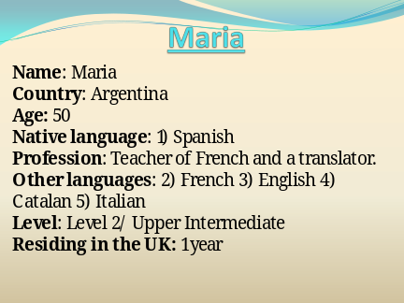 | ___________________________________  ___________________________________  ___________________________________  ___________________________________  ___________________________________  ___________________________________  ___________________________________
Slide 2 | 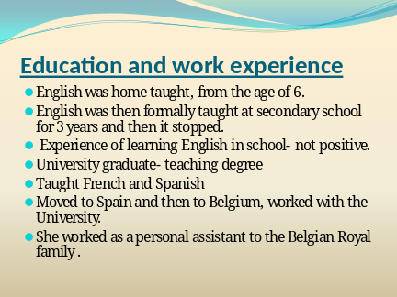 | ___________________________________  ___________________________________  ___________________________________  ___________________________________  ___________________________________  ___________________________________  ___________________________________
Slide 3 | 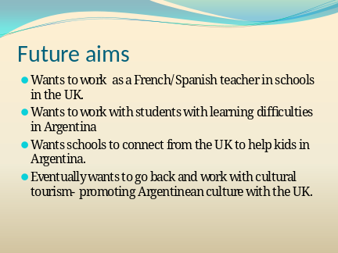 | ___________________________________  ___________________________________  ___________________________________  ___________________________________  ___________________________________  ___________________________________  ___________________________________
Slide 4 | 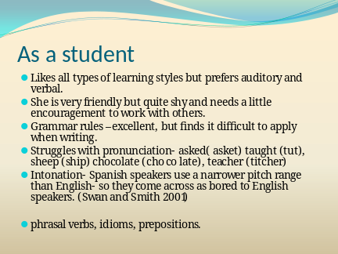 | ___________________________________  ___________________________________  ___________________________________  ___________________________________  ___________________________________  ___________________________________  ___________________________________
Slide 5 | 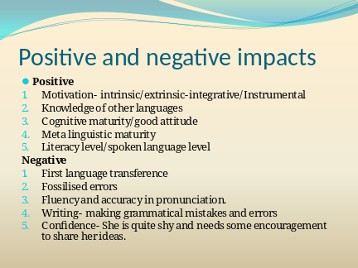 | ___________________________________  ___________________________________  ___________________________________  ___________________________________  ___________________________________  ___________________________________  ___________________________________
Slide 6 | 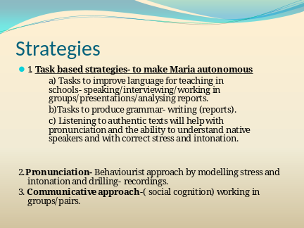 | ___________________________________  ___________________________________  ___________________________________  ___________________________________  ___________________________________  ___________________________________  ___________________________________
Slide 7 | 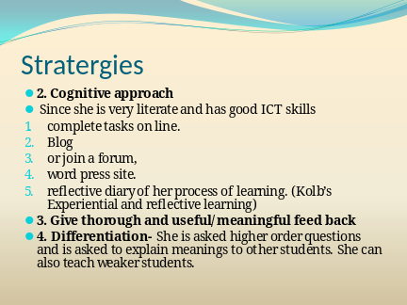 | ___________________________________  ___________________________________  ___________________________________  ___________________________________  ___________________________________  ___________________________________  ___________________________________

The World’s Greatest Goal Achiever
www.johngoddard.info

John Goddard, one of the world's most famous anthropologists, explorers, and adventurers, passed away Friday, May 17th in Glendale, CA, after battling a rare form of cancer.

Goddard will be remembered as the world's greatest goal achiever and survivor of numerous edge-of-death experiences through his 88 1/2 years of life. He documented his adventures on film and showed them to thousands of youth and adults across the globe, inspiring them to set and achieve goals. His motto was: To dare is to do - to fear is to fail.

One rainy afternoon, an inspired 15-year old boy named John Goddard sat down at his kitchen table in Los Angeles and wrote three words at the top of a yellow pad, "My Life List." Under that heading he wrote down 127 goals. These were not simple or easy goals. They included climbing the world's major mountains, exploring from source to mouth the longest rivers of the world, piloting the world's fastest aircraft, running a mile in five minutes and reading the entire Encyclopaedia Britannica.

Goddard completed all but a few of the goals from his original bucket list and hundreds more from subsequent lists. He became the first man in history to explore the entire length of the world's longest river, the Nile, in a gruelling 4,160 mile, nine month kayaking expedition which the Los Angeles Times called "the most amazing adventure of this generation." He then matched that achievement and became the first man ever to explore the entire length of the Congo River (also by kayak), and he scaled the Matterhorn in a raging blizzard after several professional guides had refused to go along.

At the age of 18 he enlisted in the Army Air Force and was stationed in Foggia, Italy with the 15th Air Force 463 Bomber Squadron for three years. After serving in World War II and receiving numerous honours, he established records as a civilian jet pilot, including a speed record of 1,500 mph in the F-111 Fighter-Bomber, and an altitude record of 63,000 feet in the F-106 Delta Dart.

A graduate of the University of Southern California where he majored in anthropology and psychology, Goddard studied the effects of modern civilization on obscure cultures throughout the world. In addition, he climbed 12 of the world's highest mountains, conducted 14 major expeditions into remote regions, traversed 15 of the world’s most treacherous rivers, visited nearly every country of the world, studied 260 primitive tribes, and travelled in excess of one million miles during his adventurous life, the equivalent of 45 times around the world.

Goddard was attacked by vicious hippos and crocodiles, bitten by a poisonous snake, charged by a rampaging elephant and rhino, almost buried alive in a blinding sandstorm, shot at by Egyptian river pirates, stoned by a mob of hostile natives, survived desert temperatures of over 140 degrees, weakened by malaria and dysentery, and trapped in quicksand. He has survived a plane crash, been caught in earthquakes, and almost drowned four times while running rapids and deep sea diving.

Goddard was honoured by the Encyclopaedia Britannica as a recipient of the “Achievement in Life Award.”

Goddard has been the subject of numerous articles in magazines such as National Geographic, Life, People, and Reader’s Digest and appeared in over 200 television talk and adventure shows. He has been the guest of such television personalities as Bob Hope, Johnny Carson, and David Frost.

Goddard is the author of two books:

Born July 29, 1924 in Salt Lake City, Utah he is survived by his wife of 33 years, Carol, six children, and twelve grandchildren.

Table 1 (written text)
Grammatical concept Tenses and Aspects
Type | Example | Comments
Past simple | Passed away Friday, May 17th, he documented his adventures..and showed them to ..Goddard completed but a few...Goodard sat down, he wrote down three words | Used for past, finished actions which tell the main events in the story.
Past continuous | After battling a rare form of cancer.
Past perfect | Goddard was attacked, bitten by a poisonous snake, charged by a rampaging elephant, almost buried alive, shot at by, stoned by a mob, survived desert temperatures, | To talk about actions or situations that were completed before another action in the story. The actions are often mentioned out of time sequence and the past perfect makes the order clear
Present perfect | He survived a plane crash, been caught in earthquakes, Goddard has been the subject of numerous articles, | Shows that an action is completed, however it still has some importance in the present time
Present simple | Goddard is the author of two books, he is survived by his wife, | Here the present simple is used to show statements of fact.
Future simple | Goddard will be remembered. | To talk about an event in the future

Grammatical Concept  Sentence and phrase level |  | comments
Sentences simple | Under that heading he wrote down 127 goals. | Consist of one clause, in which the verb is finite.
Sentences complex | He became the first man in history to explore the entire length of the world’s longest river, the Nile, in a gruelling 4160 mile, nine month kayaking expedition which the Los Angeles Times called the “most amazing adventure of this generation”. | Those that contain a subordinate clause as well as a main clause. These clauses are of three types adverbial relative, and noun.  The subordinate clause is in italics and underlined
Sentences compound | Goddard will be remembered as the world’s greatest goal achiever and survivor of numerous edge-of –death experiences through his 881/2 years of life. One rainy afternoon, an inspired 15-year old boy named John Goddard sat down at his kitchen table in Los Angeles and wrote three words at the top of a yellow pad, "My Life List." | Two statements are given equal weight with the use of a conjunction.
Noun phrases | After batting a rare form of cancer. the most amazing adventure, first man in history, source to mouth, the entire length, one rainy afternoon, edge-of-death experiences, easy goals, bucket list, World War 2,civilan jet pilot, speed record, modern civilisation, across the globe.
Nouns- names of places | Glendale CA, Foggia Italy, Salt Lake City Utah, University of Southern California
Nouns – names of written texts | Encyclopaedia Britannica, Los Angeles Times, National Geographic, Life People, Reader’s Digest.
Nouns- names of people | Bob Hope, Johnny Carson, David Frost, Carol.
Pronouns- anaphoric reference | He documented his adventures.
Articles | At the age of 18. A graduate from the University of Southern California
Phrasal verbs | Sat down, wrote down | A phrasal verb is a type of verb created when a main verb is combined with either an adverb, a preposition, or an adverb or proposition
Verbs-active | Documented, showed, wrote, climbed ,conducted, traversed, visited, studied, travelled, | To describe an action, and to show who carried out the action.
Verbs -passive | Goddard was attacked by vicious hippos and crocodiles, bitten by a poisonous snake, charged by a rampaging elephant and rhino, almost buried , shot at, stoned by | To show that the subject is not the person that does the action of the verb. It is the person that is acted on by the verb.
Lexical choices –auxiliary verbs | Goddard has been the subject of numerous articles. Goddard was honoured by the Encyclopaedia | Be is a primary auxiliary used to construct compound tenses.

Grammatical concept –word level
adjectives | Amazing adventures, treacherous rivers, adventurous life, vicious life, poisonous snake, rampaging elephant, blinding sandstorm raging blizzard.
superlatives | World’s greatest goal achiever, world’s longest river, worlds highest mountains | Superlatives have been used to emphasise that Goddard exceeded in his qualities and his achievements.
Prepositions/adverbs | Attacked by vicious hippos, bitten by a poisonous snake, through his 881/2 years of life | Some prepositions can also be used as adverbs
prepositions | Appeared in, he documented his adventures on film, caught in earthquakes, travelled in,

Table 2 (Spoken text)- Steven’s story
Features of spoken discourse
Back channelling-short words to show active listening | ---
Discourse markers-to mark boundaries from one topic to the next | ---
Ellipses- missing out words to avoid repetition | ---
Fillers-used for thinking time | He is very special because he refuses to let this beat uhm him or uhm or govern the rest of his life
General words- unspecified vague words | ---
Hedges-to soften the language | It’s made lots of young people here think quite differently about the sort of decisions they are making and how they need to make the best of their opportunities.
Interactional language-social and personal to establish and maintain interpersonal relationship | ----
Incomplete sentences | ----
Tags- questions to establish a shared view of things or to seek confirmation | ----
Vague language-to soften utterances and not sound too direct
Intonation- refers to the rise and fall of the voice, the musical pitch of the voice
Stress- used to emphasise particular parts of utterances and draw the listeners’’ attention to them. | This is not a sob story, this is Steven’s story. It was a huge kick up the backside that gave me a lot of motivation for life. The amount of opportunities that have come my way is absolutely immense and the one thing I’ve really enjoyed is the fundraising and helping others. That’s the main thing I want to concentrate on.
contractions | I’ve. it’s, don’t, I may have cancer but cancer doesn’t have me.
Deixis: refers to words and phrases that cannot be fully understood without additional contextual information | It’s made lots of young people here think quite differently about the sort of decisions they are making and how they need to make the best of their opportunities.
Expression and body language
Colloquial language | -
conjunctions | but when life gives you cancer

Examples that make the text coherent
Anaphoric reference | Refers back to other ideas | He was going through chemo once a fortnight
Cataphoric reference | Refers to ideas later in the text | ---
Exophoric reference | Points to something outside the language of the text | It’s made lots of young people here think quite differently about the sort of decisions they are making and how they need to make the best of their opportunities.
conjunctions | Joining words | but when life gives you cancer, One week after the original operation to remove tumours from my bowel and one day after leaving hospital, I ended up going to a fancy dress party. The surgeon gave me advice and to go home and take it easy and basically do nothing but I decided to go to this party.

Lexical Cohesion
repetition |  | Kick up the backside, bucket list
synonyms |  | Amazing, exceptional, special, wonderful
Words from same lexical field |  | Charity, fundraising, raising money, bucket list

Tenses
Past simple | I decided to go to this party.
Past continuous | He was going through chemo once a fortnight,
Present perfect simple | Since I ‘ve done my bucket list. I’ve had to refuse erm and decided to give the money to charity instead.
Present perfect | that it’s inspired and motivated so many people
Present simple | He is very special because he refuses to let this beat uhm him

Sentences
Simple sentences | I was diagnosed in September 2012.
Compound sentences | One week after the original operation to remove tumours from my bowel and one day after leaving hospital, I ended up going to a fancy dress party.
Complex sentences

Rhetorical question: what do you do when life gives you cancer?
Idioms: Kick up the backside, stick two fingers up.

LESSON PLAN

Topic/Aims: | To provoke discussion about things they would like to do in their lifetime (bucket lists) using the second conditional “if”.
Objectives: | To be able to talk about things they would like to do in their lifetime  To be able to express an opinion about an authentic text they have listened to  To be able to make a short list  To be able to pick out information whilst listening listen to an authentic text at natural speed and answer questions  To be able to practice using the second conditional “if”
In Class activity: | SS will discuss in pairs and groups what they would like to do in their lifetime, and what they would add to their “bucket list”  SS will try and predict what “Stephen’s story” is about.  SS will listen to Stephen’s story about his “bucket list” and answer gist and detailed comprehension questions and give opinions about it  SS will complete a guided discovery grammar lesson based on the second conditional.  SS will play game- like language practice procedures using the second conditional  SS will practice writing using the second conditional
Some students should also: | Be able to answer higher order questions.
Some students could also: | Peer teach each other.
Health and Safety: | Need to check the room is warm enough and check that all cables are out of the way and room layout is comfortable. Check fire exits

Time: | Teacher & Support activity: | Student Activity: including Differentiation | Assessment | Resources:
Warmer  5 minutes | Show some pictures and ask students what they are and whether anyone has done them.  1.bungee jumping  2. swimming with dolphins  3. rock climbing  4. sky diving | Ss look at pictures and answer questions regarding the pictures | To assess their knowledge of vocabulary and pronunciation. | Pictures on power point
Lead in  5 minutes | Show questions on power point and ask SS to discuss. | In pairs SS discuss in pairs the questions | To activate schema and to create an interest in the topic. | Questions on power point
Pre teach vocabulary  10  minutes | Group the SS in 3’s and hand out 3 words to each group. Ask SS to work out the meaning. Give them 5 minutes. if they cannot work out meaning then they can look the words up in the dictionaries. Then ask them to explain the meaning to the other groups. Then put up the meaning on the slides.  Model and drill words for pronunciation. | SS in groups look at the words and try and work out the meanings first and then with dictionaries, and then explain the meanings to the other groups. | to assess their knowledge of vocabulary by asking concept check questions. To assess pronunciation. | Cut out words
Prediction  3 minutes | Ask students to predict what the video “Steven’s Story” will be about by trying to work it out from the vocabulary | SS in pairs try to predict what “Steven’s story” will be about. | To hypothesise specific issues that may be raised by asking questions | PowerPoint slide
Video and gist question  5/7 minutes | Play the recording until 4.04 minutes and ask if their predictions were correct. Give feedback. | SS listen to the recording and then decide if their predictions were correct. | By asking questions | video
Detailed questions  10 minutes | Hand out some questions regarding the video and ask SS to answer the questions whilst listening. Ask them to read the questions first. Play the recording again. Ask SS to compare answers. Elicit answers and give feedback. | SS read the questions and answer the questions whilst listening. Then SS compare answers with a partner. | Detailed comprehension questions. | Comprehension questions
Grammar- second conditional  10 minutes | .  Hand out sentences with matching halves. Ask the students in pairs to match sentences with the endings. Show answers on slides. Then ask the SS in pairs whether they agree or disagree. | SS in pairs match the sentences with the endings. | To be able to assess their knowledge of the second conditional | Cut up questions  Power Point slide with answers
15 minutes | Ask SS what the “if” means in the sentences and then hand out guided discovery rules and ask them to complete the rules by looking at the sentences from the previous exercise. SS peer check and then elicit answers from students and show answers on Power Point. give feedback. | SS in pairs work out the rules of the second conditional.  SS in pairs work out the rules by looking at the sentences from the previous exercise. SS peer check with other pairs and then self check. | To be able to assess their knowledge of the rules of the second conditional. | Rules handout  Power Point slide with answers.
15 minutes | Ask SS to play the personality test game. Hand out questions to SS and they have to answer a, b or c. Each answer is a point and then they ask their partner to calculate their points to see how truthful they are. In feedback as who had the most scores and who had the least. | SS play the personality test game and answer a, b or c. Each answer has a point and then their partner adds up the points to reveal the total score. Then they ask their teacher the questions. | To be able to assess their ability to ask themselves questions in unlikely events | Questions and score card.
10 minutes | Ask SS to play a game. Give the class one “if” clause “If I won the lottery, I would....” Elicit an answer from the class then ask the SS to take turns and the next SS takes the results and reforms it into a condition and suggests a further result and so on. | SS play chain story game. | To further practice the second conditional
5 minutes | Write on board. If I were a colour what would I be? If I were an animal which animal would I be? Write a few more. Ask SS to answer these questions and then ask their partner the questions. Then elicit answers and give feedback. | SS answer questions on board and then ask their partners. | To further practice asking questions using the second conditional | Questions on board
Speaking/writing task  15 minutes | Ask SS to write 5 things that would be on their bucket list if they had the time and money to do anything. Monitor and give help with vocabulary. First they discuss it with their partner then 2 pairs join the group and discuss and then 2 pairs join again and discuss what they have on their list and why. Elicit some answers and give feedback | SS write down 5 things they would like on their bucket list. Then SS discuss with a partner, then with another pair and then another. They explain why they would like to do it. | To give freer practice | SS notebooks
5 minutes | Ask SS if they had heard of Steven. What did they think about what he did? Show them his face book page. Tell them that he no longer lives. | SS discuss the video and discuss their thoughts on Steven. | To bring closure to this part of the lesson, ask them questions.

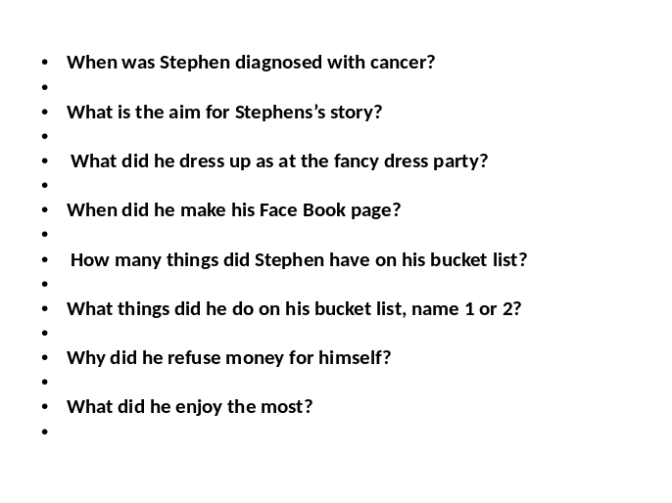
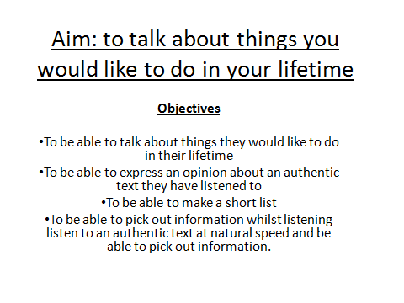
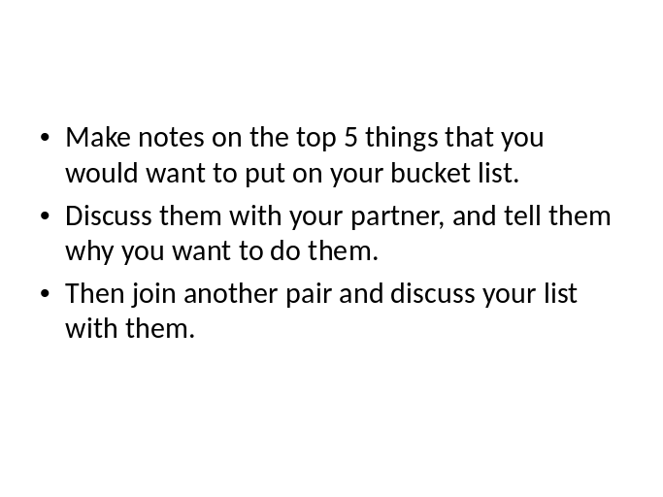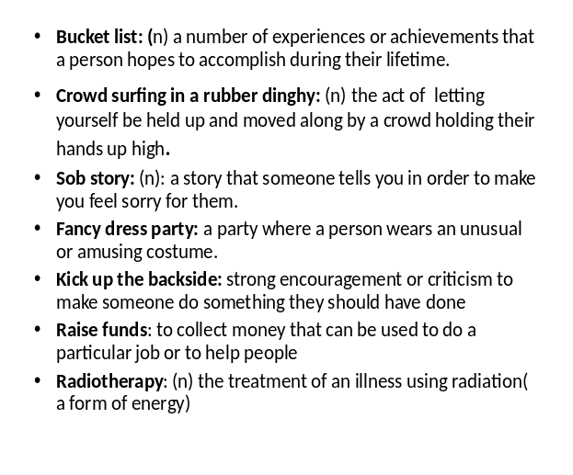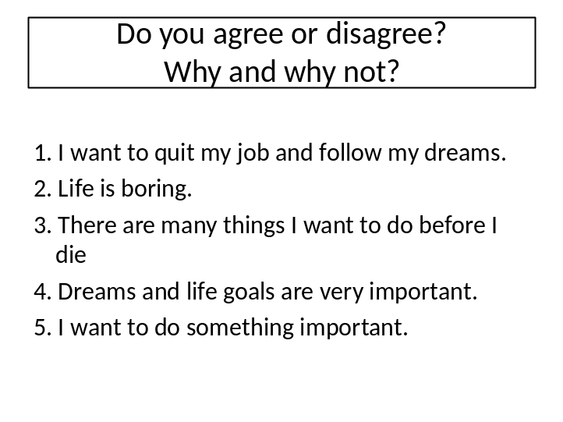

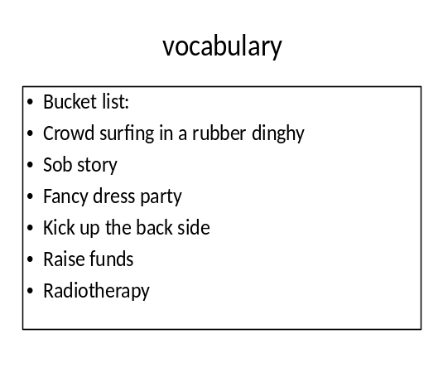

Grammar resources

1. If developing countries received better aid and resources, there would be less poverty.
2. If everyone volunteered abroad and understood foreign cultures better, there would be fewer wars.
3. If people caused global warming, it would be wise to pollute less and recycle more
4. If we found life in the solar system, it could mean the survival of our planet.
5. If the US attacked Russia, it might be the end of the world.
6. If everyone owned a Ferrari, there would be a lot of accidents.

Do you agree or disagree?

Guided discovery –rules
Look at the sentences from the previous exercise and work out the rules.
1. The second conditional is a structure to describe real/unreal or unlikely events in the future.
2. The second conditional consists of two clauses
a) an if clause and a main clause
b) an if clause and a subordinate clause
3. Look at the sentences and check if this is correct
IF-CLAUSE is If+ subject + past tense verb + object/complement
MAIN CLAUSE is subject + would + main verb + object/complement
4. Is there a comma between the if-clause and the main clause?
5. Can the clauses be structured the other way round? ( Main clause + If clause).
For example: There would be a lot of accidents if everyone owned a Ferrari.
Is there a comma used here?
6. Can modal verbs such as could, might and should be used instead of would?
7. Which sentence is correct?
If I were rich, I would own many cars
If I was rich, I would own many cars.

Game: How honest are you?
1. If you saw an old man steal biscuits from a shop, what would you do?
a) Talk to the manager
b) Talk to the old man
c) Nothing.
2. If you found a wallet in the street with money and documents what would you do?
a) Keep the money and return the documents
b) Return everything
c) Keep the money and the documents.
3. If you found your partner’s personal diary open on the table, what would you do?
a) Read it and not tell your partner
b) Read it and tell your partner
c) Ignore it.
4. If a friend was wearing some horrible clothes, what would you say if he/she asked your opinion?
a) “You look great!”
b) “You look ridiculous”
c) “I must go, I’m late”.
5. Your friends have invited you to a party and you feel too lazy to go. What would you do?
a) Telephone them and tell the truth.
b) Telephone and lie
c) Not telephone and hope nobody notices.
6.If the cashier in the shop gave you too much change, what would you do?
a) tell the cashier and give the money back.
b) say nothing and feel happy about it.
c) say nothing and feel bad about it.
7. If you crashed into a car in the car park, what would you do?
a) Leave your name and address on a piece of paper.
b) Wait for the owner.
c) Drive away quickly
8. If you saw your best friend’s partner kissing another person, what would you do?
a) Tell your partner
b) Speak to your friend’s partner
3) Wait and see what happens.
Calculate your score
1. A=3 B=2 C=1
2. A=2 B=3 C=1
3. A=1 B=2 C=3
4. A=1 B=3 C=3
5. A=3 B=3 C=2
6. A=3 B=1 C=2
7. A=2 B=3 C=1
8. A=3 B=2 C=1
Now ask your teacher these questions

